**TASK 8**

**Deploying an Application   
using AWS CodePipeline on   
ECS EC2 with Terraform**

**Umar Satti**

Table of Contents

Task Description 3

Architecture Diagram 3

Tasks 4

Task 1.1: Flask Application and Dockerfile Configuration 4

Task 1.2: Terraform Structure 6

Task 1.3: S3 Bucket for Terraform Remote Backend 7

Task 1.4: Root Directory Files 8

Task 1.5: VPC Module 12

Task 1.6: ECR Module 13

Task 1.7: Task Definition Module 14

Task 1.8: ECS Module 16

Task 1.9: ALB Module 17

Task 1.10: CodeBuild Module 18

Task 1.11: CodePipeline Module 20

Task 1.12: Execute Terraform Commands 21

Task 1.13: Validate Infrastructure in AWS Console 22

Task 1.14: Deploy Flask Application via CodePipeline 33

Task 1.15: Confirm Flask Application is Accessible 33

Task 1.16: Clean Up 33

Task 1.17: Troubleshooting 34

# Task Description

This project demonstrates a complete CI/CD pipeline for deploying a Python Flask web application on Amazon ECS using EC2 launch type with AWS CodePipeline. The infrastructure includes a highly available VPC with public/private subnets, Application Load Balancer (ALB), private ECR repository, ECS cluster with Auto Scaling Group (ASG), CodeBuild for Docker image building, and CodePipeline orchestrated from GitHub source code. All resources are provisioned using Terraform with modular architecture.

# Architecture Diagram

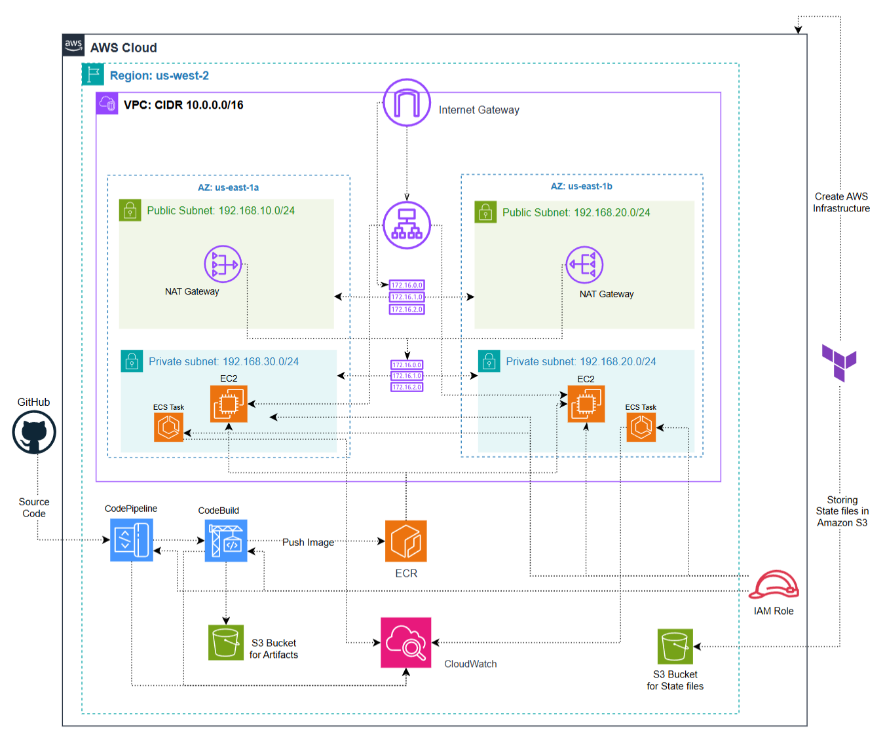

# Tasks

## Task 1.1: Flask Application and Dockerfile Configuration

The first step of the project is containerizing a **Python Flask application** that serves a webpage on port 5000. This image will be uploaded to ECR and deployed on ECS EC2.

**Step 1: Create Flask Application (app.py)**

* Implements a simple Flask app with one route (/).
* Returns an HTML page with main heading and secondary heading.
* Runs on **port 5000** and binds to 0.0.0.0 so ECS can route traffic to the container.

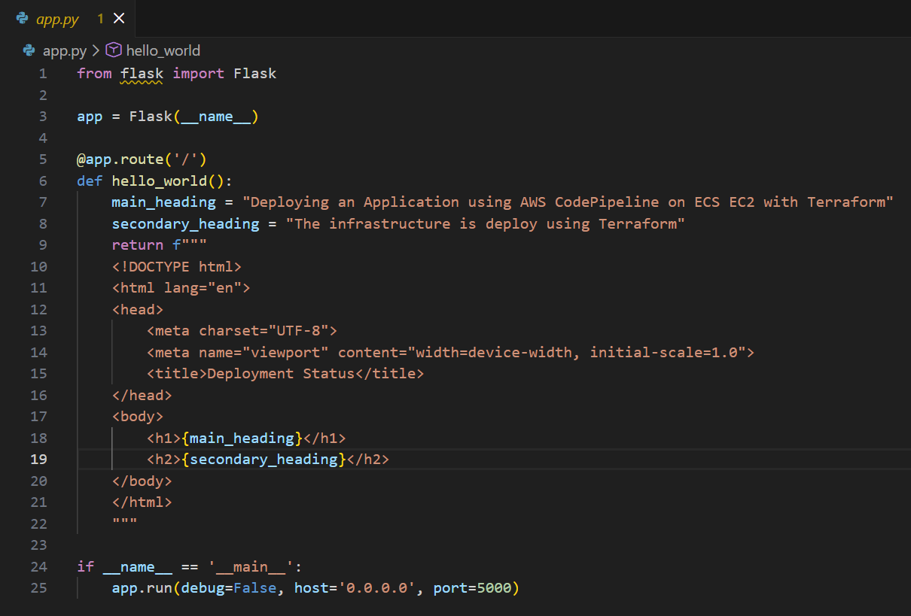

**Step 2: Create requirements.txt**

* Lists all Python dependencies.
* Contains ***Flask==3.1.2*** to ensure the Flask app runs inside the container.
* Keeps builds reproducible across environments.

**Step 3: Create Dockerfile**

* **Base image:** python:3.13-alpine for a lightweight Python environment.
* **Working directory:** /app inside the container.
* **Copy and install dependencies:**
  + requirements.txt is copied and installed via pip.
* **Copy application code:** app.py is added to the container.
* **Expose port 5000:** Matches the Flask app, allowing ALB and ECS to route traffic.
* **Run the app:** CMD ["python", "app.py"] starts Flask in the container.

**Step 4: Test Locally**

1. Build the Docker image using ***docker build -t flask-app:latest .***
   * Validates the Dockerfile.
   * Produces a container image ready for ECS deployment.

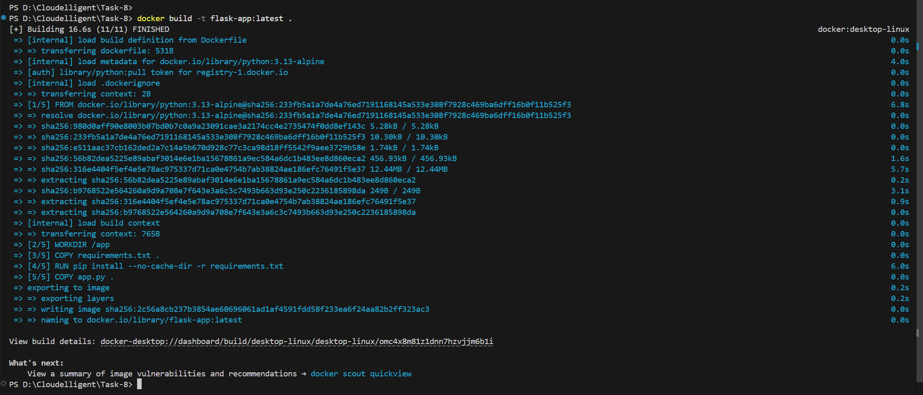

1. Run container using ***docker run -d -p 5000:5000 --name flask-app flask-app:latest***
   * Maps local port 5000 to container port 5000.
   * Confirms the Flask app is accessible locally.

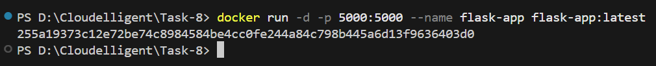

1. Verify:
   * ***docker ps -a*** command shows the container is running.
   * Open http://localhost:5000 to confirm the webpage displays correctly.



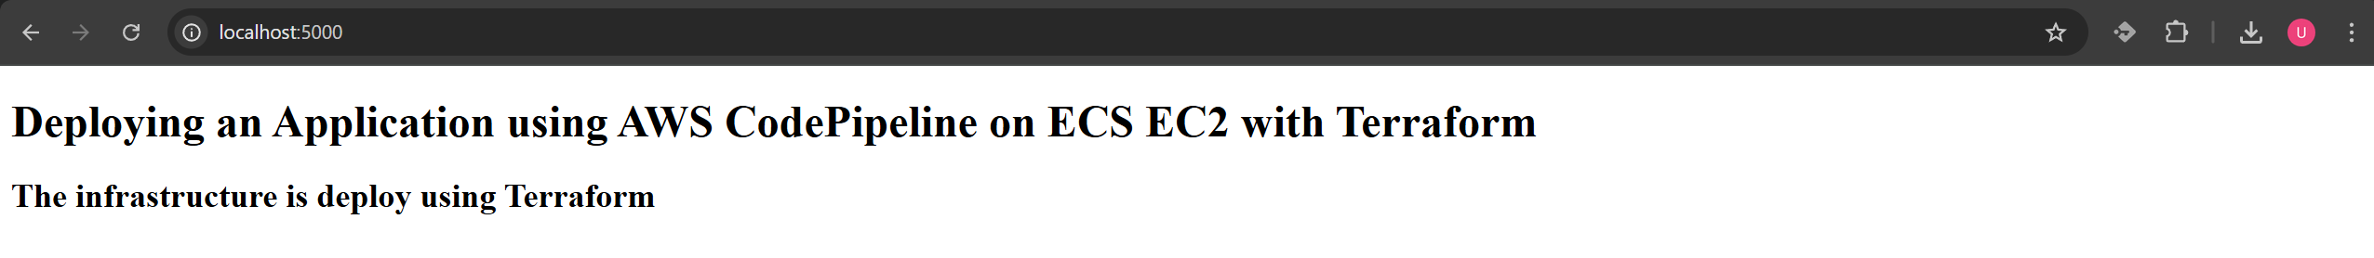

## Task 1.2: Terraform Structure

**Steps:**

1. Create a terraform.tf file in the root directory. This file defines the AWS provider, provider version, AWS region, and the S3 backend for storing Terraform state files.
2. Create an S3 bucket in the same AWS region to store Terraform state files (explained in Task 1.3 below).
3. Create a main.tf file in the root directory. This connects modules together, passes outputs from one module to another, and passes variables between them.
4. Create a variables.tf file in the root directory. This file defines variables by description and type as key-value pairs. These contain arguments for parameters such as VPC name, CIDR block, ECR URIs, and more.
5. Create an outputs.tf file in the root directory. This file exposes important module outputs such as ALB DNS name after deployment.
6. Create a modules directory that contains 7 total modules including VPC, Task definition, ECR, ECS, ALB, CodePipeline, and CodeBuild. Each module contains its own individual main.tf, variables.tf, and outputs.tf files.

## Task 1.3: S3 Bucket for Terraform Remote Backend

**Steps:**

1. Log in to the AWS Management Console. Navigate to S3 using the search bar at the top of the console page.
2. Click on **Create Bucket** button.
3. Choose **General Purpose**, add a globally unique bucket name, and make sure the AWS Region is the same as Terraform.
4. Click **Create Bucket**.
5. Update **terraform.tf** file in root directory to reference this S3 bucket in the backend block.

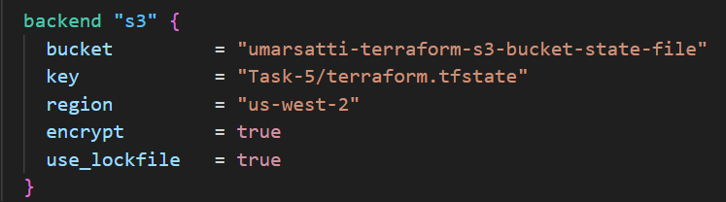

Once the S3 bucket is created in the AWS Management Console and referenced in the Terraform backend configuration, Terraform automatically begins storing and versioning state files in this bucket. In this case, the S3 bucket named **umarsatti-terraform-s3-bucket-state-file** is used as the remote backend, as defined in the **provider.tf** file. The backend block ensures all state information is centralized, secure, and persistent across multiple users or workstations.

The screenshot shown below shows the exact file path inside the S3 bucket:  
**S3 > Buckets > umarsatti-terraform-state-file-s3-bucket > Task-8 > terraform.tfstate**

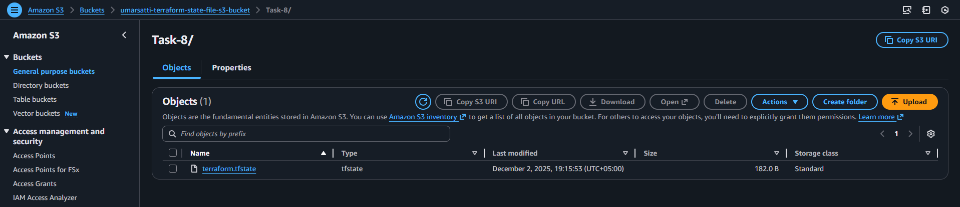

This confirms that:

* Terraform successfully initialized the backend and wrote the state file to the S3 bucket.
* The **terraform.tfstate** file contains metadata about all deployed AWS resources (VPC, Subnets, Security groups, etc.).
* Every terraform plan, apply, or destroy operation reads and updates this file automatically.
* The locking mechanism (enabled by **use_lockfile = true**) ensures that no two processes modify the state simultaneously, preventing state corruption.

## Task 1.4: Root Directory Files

Terraform root directory acts as the orchestration layer for all AWS infrastructure.  
While each AWS service (VPC, ALB, ECS, ECR, Task Definitions, CodeBuild, CodePipeline) is defined in its own module, the root directory ties everything together by:

* Defining the backend and AWS provider.
* Supplying variables into each module.
* Connecting module outputs to other modules (e.g., ECR → Task Definition → ECS).
* Managing environment-specific configuration with terraform.tfvars.
* Exposing global outputs after deployment.

This keeps the project modular, reusable, and maintainable.

**terraform.tf**

This file configures how Terraform runs and where it stores its state.

**Purpose**

* Declares the required AWS provider version.
* Defines the remote backend (S3 bucket) for storing the Terraform state file.
* Enables state locking to prevent concurrent modifications.
* Sets the deployment region.

**Key points**

* Using an S3 backend ensures collaboration and prevents state loss.
* State locking improves safety when multiple people run Terraform.
* The AWS provider block ensures all modules use us-east-1.

**main.tf**

This is the central “orchestration” file that wires all modules together.

**Purpose**

* Loads modules for **VPC, ECR, Task Definition, ECS, ALB, CodeBuild, and CodePipeline**.
* Passes variables to each module.
* Feeds outputs (e.g., subnets, image URI, target group ARN) into downstream modules.
* Automatically creates dependency order between infrastructure components.

**High-level flow**

1. **VPC module** builds networking (VPC, public/private subnets, IGW, security groups).
2. **ECR module** creates private container registry.
3. **Task Definition module** builds the ECS Task Definition using the ECR image and CloudWatch Logs.
4. **ALB module** creates an Application Load Balancer and Target Group.
5. **ECS module** deploys the ECS Cluster and Service, wiring in VPC networking, Task Definition ARN, and ALB target group.
6. **CodeBuild module** sets up the CI build environment inside the VPC.
7. **CodePipeline module** creates the end-to-end deployment pipeline, linking GitHub → CodeBuild → ECS.

This structure ensures clean separation of responsibilities while keeping the root module in control of the overall architecture.

**variables.tf**

Defines all input variables used across the root and module configurations.

**Purpose**

* Makes the project configurable, reusable, and environment-agnostic.
* Provides typed variables with descriptions, improving validation and readability.
* Allows module inputs to be managed from a central place.

Examples of variable groups:

* **Networking variables** (VPC CIDR ranges, names).
* **ECR variables** (repo name, encryption options).
* **Task Definition variables** (CPU, memory, container name, logs).
* **ECS variables** (cluster/service names, instance type, IAM roles).
* **ALB variables** (ports, names, target type).
* **Pipeline variables** (pipeline name, GitHub connection, S3 bucket).

**terraform.tfvars**

Provides the actual values for the variables defined in variables.tf.

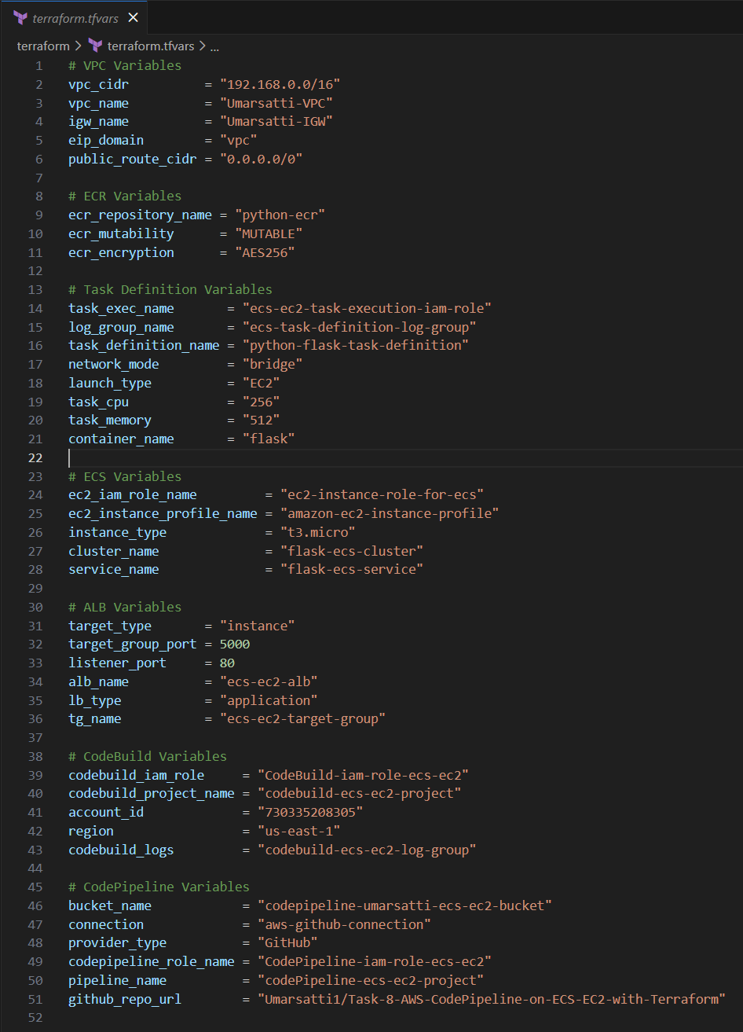

**Purpose**

* Keeps configuration separate from logic.
* Allows easy switching between environments (e.g., dev, test, prod).
* Supplies concrete values for all networking, compute, container, ALB, CI/CD, and IAM parameters.

This enables the same Terraform code to deploy different setups simply by swapping tfvars files.

**outputs.tf**

Exposes key information after deployment.

**Common outputs**

* **ECR repository URI** – used for pushing application images.
* **ALB DNS name** – used for accessing the application through the load balancer.
* **Cluster and service identifiers** – useful for integration or debugging.

Outputs make it easy to retrieve essential resource details without browsing the AWS console.

## Task 1.5: VPC Module

This section explains each Terraform configuration file located inside the **VPC module** (modules/vpc).

**main.tf**

**Local Variables**  
The module defines three maps to dynamically build networking resources:

* **public_subnets** – CIDRs and AZs for all public subnets (used for ALB and NAT Gateways).
* **private_subnets** – CIDRs and AZs for all private subnets (used for ECS instances running tasks).
* **private_to_nat** – Maps each private subnet to the NAT Gateway in its corresponding public subnet, ensuring correct outbound routing per AZ.

These locals allow scalable subnet creation with **for_each** meta-argument.

**VPC**  
Creates the main VPC using the CIDR passed from the root module.  
DNS support and hostnames are enabled for service discovery and internal communication.

**Public & Private Subnets**  
Both subnet types are generated dynamically from locals:

* Public subnets map public IPs on launch and host ALB and NAT Gateways.
* Private subnets remain isolated with no public IPs and are used for ECS compute.

Tags use the subnet names from locals for clear identification.

**Internet Gateway (IGW)**  
Provides internet access to all public subnets. Required for NAT Gateways to function.

**Elastic IPs and NAT Gateways**  
Each public subnet gets:

* Its own **Elastic IP**
* Its own **NAT Gateway**

This guarantees high availability and ensures private subnets can reach the internet (e.g., pull images from ECR) without being publicly exposed.

**Route Tables & Routes**

* **Public Route Tables:** One per public subnet, routing 0.0.0.0/0 through the IGW.
* **Private Route Tables:** One per private subnet, routing outbound traffic through the NAT Gateway mapped via private_to_nat.

Associations link each subnet to the correct route table.

**Security Groups**  
Two security groups support ALB → ECS traffic flow:

1. **ALB Security Group**
   * Allows inbound HTTP (port 80) from anywhere.
   * Egress is fully open.
   * Used by the ALB.
2. **ECS/EC2 Security Group**
   * Allows inbound traffic only from the ALB security group on:
     + Port **5000** (your Flask app)
     + Ephemeral ports (32768–65535) for ALB health checks
   * Outbound traffic is fully open.
   * Used by ECS EC2 instances and tasks.

This ensures ECS tasks are private and only reachable through the ALB.

**variables.tf**

The VPC module accepts five variables:

* **vpc_cidr** – The VPC’s IP range.
* **vpc_name** – Tag for the VPC.
* **igw_name** – Tag for the Internet Gateway.
* **eip_domain** – Domain setting for NAT EIPs.
* **public_route_cidr** – Destination CIDR for public and private routes (usually 0.0.0.0/0).

These variables keep the module flexible and reusable.

**outputs.tf**

The module exposes essential network details for downstream modules:

* **vpc_id** – Needed by ALB, ECS, and CodeBuild modules.
* **public_subnets** – Used by ALB, NAT Gateways, and ECS if required.
* **private_subnets** – Used by ECS tasks and CodeBuild.
* **alb_sg_id** – Passed to the ALB module.
* **ec2_ecs_sg_id** – Passed to the ECS module for instance/task security.

These outputs allow the VPC module to integrate cleanly with the rest of the infrastructure.

## Task 1.6: ECR Module

This section explains each Terraform configuration file located inside the **ECR module** (modules/ecr).

**main.tf**

The module creates a single **Amazon ECR repository** used to store container images for the ECS service.

Key points:

* **name** comes from ecr_repository_name, allowing different repositories per environment (dev, test, prod).
* **image_tag_mutability** is controlled by ecr_mutability (e.g., MUTABLE/IMMUTABLE), defining whether image tags can be overwritten.
* **force_delete = true** ensures the repository can be destroyed even if images exist, preventing cleanup issues during iterative development.
* **encryption_configuration** uses the value in ecr_encryption (such as AES256) to secure all images at rest.
* **image_scanning_configuration** disables scan-on-push, simplifying CI/CD pipelines but can be enabled later for security hardening.

This repository serves as the private storage location for the ECS application image pulled during deployments.

**variables.tf**

The module defines three input variables:

* **ecr_repository_name** – sets the name of the ECR repo.
* **ecr_mutability** – controls tag mutability.
* **ecr_encryption** – defines encryption type for stored images.

These inputs make the module fully reusable with different naming conventions or security settings.

**outputs.tf**

Two outputs provide essential information:

* **ecr_image_uri** – the full repository URL (e.g., account.dkr.ecr.region.amazonaws.com/repo), required by the Task Definition.
* **ecr_repository_name** – exposes the repo name for use in CodeBuild or pipelines.

These outputs allow other modules (Task Definition, CodeBuild, CodePipeline) to seamlessly reference the container registry.

## Task 1.7: Task Definition Module

This section explains each Terraform configuration file located inside the **Task Definition module** (modules/task_definition).

**main.tf**

This module creates everything required for an ECS Task Definition to run your container on Fargate.

**IAM Role (Task Execution Role)**

* The role (ecs_task_execution_role) is assumed by ECS tasks and allows the service to pull images and write logs.
* The AWS-managed policy **AmazonECSTaskExecutionRolePolicy** is attached, giving access to ECR, CloudWatch Logs, and Secrets Manager.

**CloudWatch Log Group**

* Creates a log group defined by log_group_name.
* Retains logs for 7 days to keep storage costs low.
* The container writes its stdout/stderr here.

**ECS Task Definition**

* Defines how the application container runs on ECS Fargate.
* family, cpu, memory, network_mode, and launch_type all come from variables to keep the module reusable.
* Both execution_role_arn and task_role_arn use the same role for simplicity.
* The container uses the ECR image passed in (ecr_image_uri:latest).
* Exposes port **5000** to the ALB.
* Configures AWS Logs driver so all container logs stream to the created CloudWatch log group.

This task definition becomes the blueprint ECS uses when running or updating your service.

**variables.tf**

This file defines all parameters required to customize the task definition:

* **ecr_image_uri** – the repository URL from the ECR module.
* **task_exec_name**, **task_definition_name**, **container_name** – naming inputs for IAM and ECS resources.
* **network_mode**, **launch_type** – Fargate compatibility settings.
* **task_cpu**, **task_memory** – resource configuration.
* **log_group_name** – CloudWatch log group name.

All variables make the module fully adaptable for different services or environments.

**outputs.tf**

* **task_definition_arn** – the full ARN needed by the ECS Service module when referencing this task.
* **container_name** – used by load balancer targets and ECS service configuration.

These outputs help connect this module to the ECS Service and ALB modules later in the deployment workflow.

## Task 1.8: ECS Module

This section explains each Terraform configuration file located inside the **ECS module** (modules/ecs).

**main.tf**

This module creates a complete **ECS EC2 cluster** environment, including compute capacity, IAM roles, launch template, Auto Scaling Group, capacity provider, and ECS service.

**AMI Lookup**

* Fetches the latest **ECS-Optimized Amazon Linux 2023** AMI.
* Ensures new EC2 instances always run the latest ECS-optimized image.

**IAM Role and Instance Profile (For EC2 Instances)**

* The EC2 IAM role is assumed by the instances running in the cluster.
* Attached policies allow:
  + ECS agent communication (AmazonEC2ContainerServiceforEC2Role)
  + SSM access for remote management (AmazonSSMManagedInstanceCore)
* The instance profile binds the IAM role to EC2 instances launched via the ASG.

**Launch Template**

Defines the configuration for EC2 instances inside the cluster:

* Uses the ECS-optimized AMI.
* Applies the instance profile.
* Assigns the security group passed into the module.
* Injects **ECS_CLUSTER=cluster_name** into userdata so the instance automatically joins the ECS Cluster.

**Auto Scaling Group**

* Launches and maintains **2 EC2 instances** across private subnets.
* Protects instances from scale-in to avoid accidental task disruption.
* Tags instances with AmazonECSManaged = true, enabling ECS-managed instance lifecycle.

**ECS Cluster**

* Creates the cluster with **Container Insights (enhanced)** enabled for monitoring.
* Enables ECS Exec for secure per-container shell access.

**Capacity Provider**

* Connects the Auto Scaling Group to ECS via a capacity provider.
* Enables **managed scaling**, allowing ECS to automatically adjust EC2 capacity based on running tasks.
* The cluster is configured to use this provider by default.

**ECS Service**

Runs your application tasks on EC2 capacity:

* Uses the task definition ARN passed from the Task Definition module.
* Maintains **2 running tasks** with rolling deployments.
* Registers the container with the ALB target group on port **5000**.
* Supports ECS Exec for troubleshooting.

**variables.tf**

This file defines all required inputs:

* Naming inputs: IAM role, instance profile, cluster name, service name.
* Settings for compute: instance type, private subnets, security group.
* References from other modules: task definition ARN, container name, target group ARN.

These variables keep the ECS module reusable and environment-agnostic.

**outputs.tf**

* **ecs_cluster_name** – Allows other modules or pipelines to reference the ECS cluster.
* **ecs_service_name** – Useful for deployment automation and ECS Exec commands.

## Task 1.9: ALB Module

This section explains each Terraform configuration file located inside the **ALB module** (modules/alb).

**main.tf**

This module provisions an **Application Load Balancer (ALB)** that distributes traffic to your ECS service.

**Application Load Balancer**

* Creates an internet-facing ALB using the name in alb_name.
* Placed in **public subnets** so external users can reach the application.
* Uses the security group passed into the module, allowing controlled inbound HTTP traffic.
* Deletion protection is disabled so Terraform can recreate the ALB when needed.

**Target Group**

* Creates a target group named with tg_name.
* Uses **HTTP** on the port specified by target_group_port.
* target_type is configurable (e.g., instance for ECS EC2 mode, ip for Fargate).
* Associated with the provided VPC.

This is where ECS tasks register as traffic targets.

**Listener**

* Creates an HTTP listener on listener_port (typically port 80).
* Forwards all incoming requests to the target group.
* Acts as the entry point for all traffic to the web application.

**variables.tf**

Defines all required ALB inputs:

* Networking inputs: **vpc_id**, public subnets, ALB security group.
* ALB settings: name, load balancer type (usually application).
* Target group and listener settings: ports, target type, target group name.

These keep the module flexible for multiple environments and architectures.

**outputs.tf**

* **alb_arn** – used by monitoring or IAM policies.
* **target_group_arn** – required by the ECS Service module to register tasks.
* **alb_dns_name** – the public URL users use to access the application.

## Task 1.10: CodeBuild Module

This section explains each Terraform configuration file located inside the **CodeBuild module** (modules/codebuild).

**main.tf**

This module creates the **CodeBuild project** responsible for building the Docker image, pushing it to ECR, and sending build artifacts to CodePipeline.

**IAM Role for CodeBuild**

* The IAM role (codebuild_role) is assumed by CodeBuild.
* Allows the project to access logs, ECR, S3, VPC resources, and networking APIs.
* Each inline policy provides specific permissions:

**CloudWatch Logs Policy**

* Allows creating log groups/streams and writing logs from CodeBuild.

**S3 Policy**

* Allows retrieving and uploading files used during builds (mainly for CodePipeline integration).

**ECR Policy**

* Enables CodeBuild to authenticate to ECR, upload image layers, and push built Docker images.

**VPC Policy**

* Required for CodeBuild to run inside private subnets (network interface creation, VPC lookups, etc.).
* Restricts network interface permissions to the provided private subnets.

**CodeBuild Project**

* Defines the build environment and links it to CodePipeline.
* Uses **amazonlinux-x86_64-standard:5.0**, with Docker enabled (privileged_mode = true) so it can build images.
* Environment variables supply:
  + AWS Account ID
  + Region
  + ECR repository name
* Sends logs to CloudWatch in the log group defined via variable codebuild_logs.

**VPC Configuration**

* CodeBuild runs entirely inside the **private subnets**, using the provided security group.
* Ensures builds happen securely without exposing the build environment to the public internet.

**variables.tf**

Defines all necessary inputs:

* Networking: VPC ID, private subnets, private security group.
* Build settings: IAM role name, project name, account ID, region, ECR repo name, and log group.
* These parameters keep the module flexible for any environment.

**outputs.tf**

* **codebuild_project_arn** – useful for IAM policies or pipeline integrations.
* **codebuild_project_name** – used by CodePipeline when connecting pipeline stages.

## Task 1.11: CodePipeline Module

This section explains each Terraform configuration file located inside the **CodePipeline module** (modules/codepipeline).

**main.tf**

This module provisions a **fully managed CI/CD pipeline** using AWS CodePipeline, integrated with GitHub (via CodeStar Connections), CodeBuild, and ECS.

**S3 Bucket for Artifacts**

* Creates an S3 bucket (bucket_name) to store pipeline artifacts.
* Public access is fully blocked to ensure security.
* force_destroy = true allows the bucket to be deleted by Terraform even if it contains artifacts.

**CodeStar Connection**

* Establishes a connection to a GitHub repository (github_connection) using the specified provider type.
* Enables CodePipeline to pull source code automatically from GitHub.

**IAM Role and Policies**

* Creates an IAM role for CodePipeline (codepipeline_role_name).
* Policies grant permissions to:
  + Access the S3 artifact bucket.
  + Use the CodeStar GitHub connection.
  + Trigger CodeBuild projects.
  + Interact with ECS (describe/update services and register task definitions).
* Ensures the pipeline can fully manage CI/CD flow without external IAM dependencies.

**CodePipeline**

Defines a three-stage pipeline:

**1. Source Stage**

* Pulls code from GitHub via the CodeStar connection.
* Detects changes automatically on the main branch.
* Outputs SourceArtifact for the next stage.

**2. Build Stage**

* Uses the CodeBuild project to build the Docker image.
* Takes SourceArtifact as input and outputs BuildArtifact.
* Ensures images are built and pushed to ECR.

**3. Deploy Stage**

* Deploys the built image to ECS.
* Uses the cluster and service names provided.
* Reads imagedefinitions.json from the build artifact to update the ECS service.

**variables.tf**

* Inputs are fully parameterized to integrate with other modules:
  + **CodeBuild**: project ARN and name.
  + **ECS**: cluster name and service name.
  + **Pipeline**: S3 bucket, CodeStar connection, provider type, pipeline name, GitHub repo URL.
* Keeps the module reusable across multiple environments.

## Task 1.12: Execute Terraform Commands

This task deploys the entire Flask application environment using Terraform. Ensure you are in the root Terraform directory.

1. **terraform init**  
   Initializes providers and backend (S3).
2. **terraform validate**  
   Checks syntax and logic for errors.
3. **terraform plan**  
   Shows planned resource creation and updates (52 to add).

1. **terraform apply --auto-approve**  
   Creates all resources, including:
   * VPC, public/private subnets, IGW, NAT gateways
   * Security groups (ALB-SG, EC2-ECS-SG)
   * ECR repository (flask-app)
   * ECS Cluster and Service
   * ALB and target group
   * CodeBuild and CodePipeline

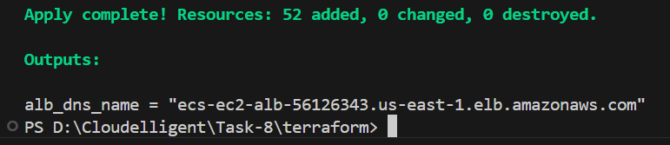

## Task 1.13: Validate Infrastructure in AWS Console

After running terraform apply, verify that Terraform successfully provisioned all AWS resources required for the Flask application deployment pipeline. This section walks through each area of the infrastructure and what you should expect to see.

**VPC & Networking**

**1. Verify VPC**

* Go to AWS Console → **VPC → Your VPCs**
* Check that the VPC created by Terraform exists.

**Expected configuration:**

* Correct IPv4 CIDR block
* **DNS hostnames enabled** (required for ALB & ECS)

**2. Verify Subnets**

Go to AWS Console → VPC → Subnets

**Public Subnets**

* 2 public subnets (Public-Subnet-A and Public-Subnet-B)
* Used for **Application Load Balancer**

**Private Subnets**

* 2 private subnets (Private-Subnet-A and Private-Subnet-B)
* Used by **ECS EC2 instances**
* Used by **CodeBuild ENIs** (if pipeline uses VPC mode)

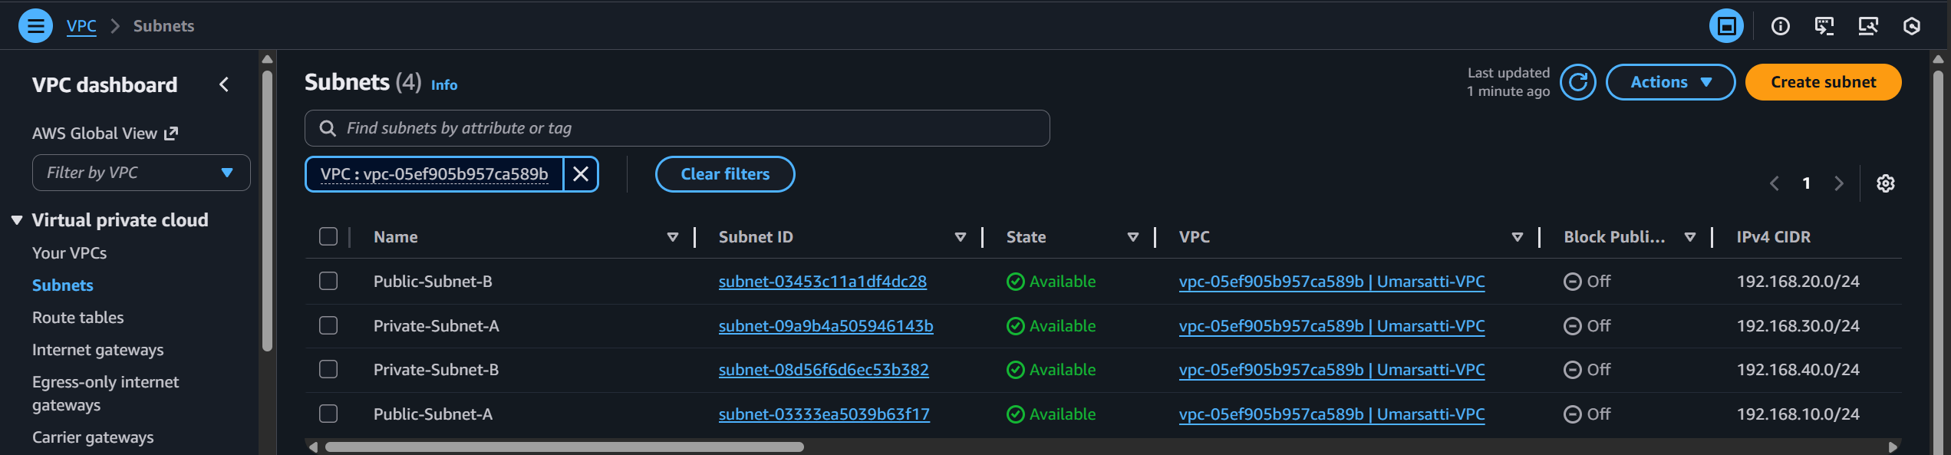

**3. Internet Gateway & NAT Gateway**

**Internet Gateway**

* Should exist and be **attached to the VPC**

**NAT Gateway**

* Should exist (depending on your architecture)
* Located in a public subnet
* Status: **Available**

Allows CodeBuild to reach ECR / S3 from private subnets.

**4. Route Tables**

Go to AWS Console → VPC → Route Tables

**Public Route Table**

* Associated with public subnets
* Has route: 0.0.0.0/0 → Internet Gateway

**Private Route Table(s)**

* Associated with private subnets
* Has route: 0.0.0.0/0 → NAT Gateway

**Security Groups**

Go to AWS Console → **VPC → Security Groups**

**ALB Security Group (ALB-SG)**

**ECS EC2 Security Group**

* Internet → ALB → ECS tasks (Flask on port 5000)

**ECR Repository**

Go to AWS Console → ECR → Private Repositories

Verify:

* **Flask repository** exists
* Repository URI looks like:

*<Account_ID>.dkr.ecr.<region>.amazonaws.com/flask-app*

Initially the image list may be empty until CodePipeline runs.

**ECS: Cluster, Service, and Tasks**

Go to AWS Console → ECS → Clusters

**Verify:**

**ECS Cluster**

* Cluster created by Terraform exists (flask-ecs-cluster)
* Launch type: **EC2**

**ECS Service**

* Service exists inside the cluster
* Status: **Active**

**ECS Tasks**

Before the first deployment, tasks may show:

* **Stopped** (because no Docker image exists yet)

After CodePipeline deploys (later):

* **Running tasks: 2/2** (or your desired count)

**Application Load Balancer**

Go to AWS Console → EC2 → Load Balancers

Verify:

**ALB**

* ALB exists
* Assigned to both public subnets
* Uses **ALB-SG**

**Listener**

* HTTP on port **80**
* Default action: forward → Flask target group

Target Group

Go to AWS Console → EC2 → Target Groups

Verify:

**Target Group**

* Target type: **instance**
* Protocol: **HTTP**
* Port: **5000**

**Health Checks**

Before first image push:

* **0 healthy targets**

**Note:** After CodePipeline deploys and tasks run:

* **Healthy targets = number of running ECS tasks**

**CodePipeline & CodeBuild**

**1. CodeBuild**

AWS Console → **CodeBuild → Build Projects**

Verify:

* Build project exists
* VPC configuration is set (if enabled)
* Buildspec includes steps for:
  + building Docker image
  + logging into ECR
  + pushing image
  + returning image tag

**2. CodePipeline**

AWS Console → **CodePipeline**

Verify:

* Pipeline exists with 3 stages:
  1. **Source (GitHub)**
  2. **Build (CodeBuild)**
  3. **Deploy (ECS)**

**Execute CodePipeline**

**Step 1: Update GitHub Connection**

Go to AWS → CodePipeline → Connections → GitHub Connection → Update Connection

**Note:** This is a mandatory first-time step

**Step 2: Run CodePipeline**

* Run pipeline manually the first time
* Wait for the pipeline stages to complete successfully.

**Step 3: Check Target Group Health**

Go to ALB → Target Groups → Health checkTarget group health should transition from **unhealthy** to **healthy**

**Step 4: Verify ECS Tasks Running**

Go to ECS → Cluster  
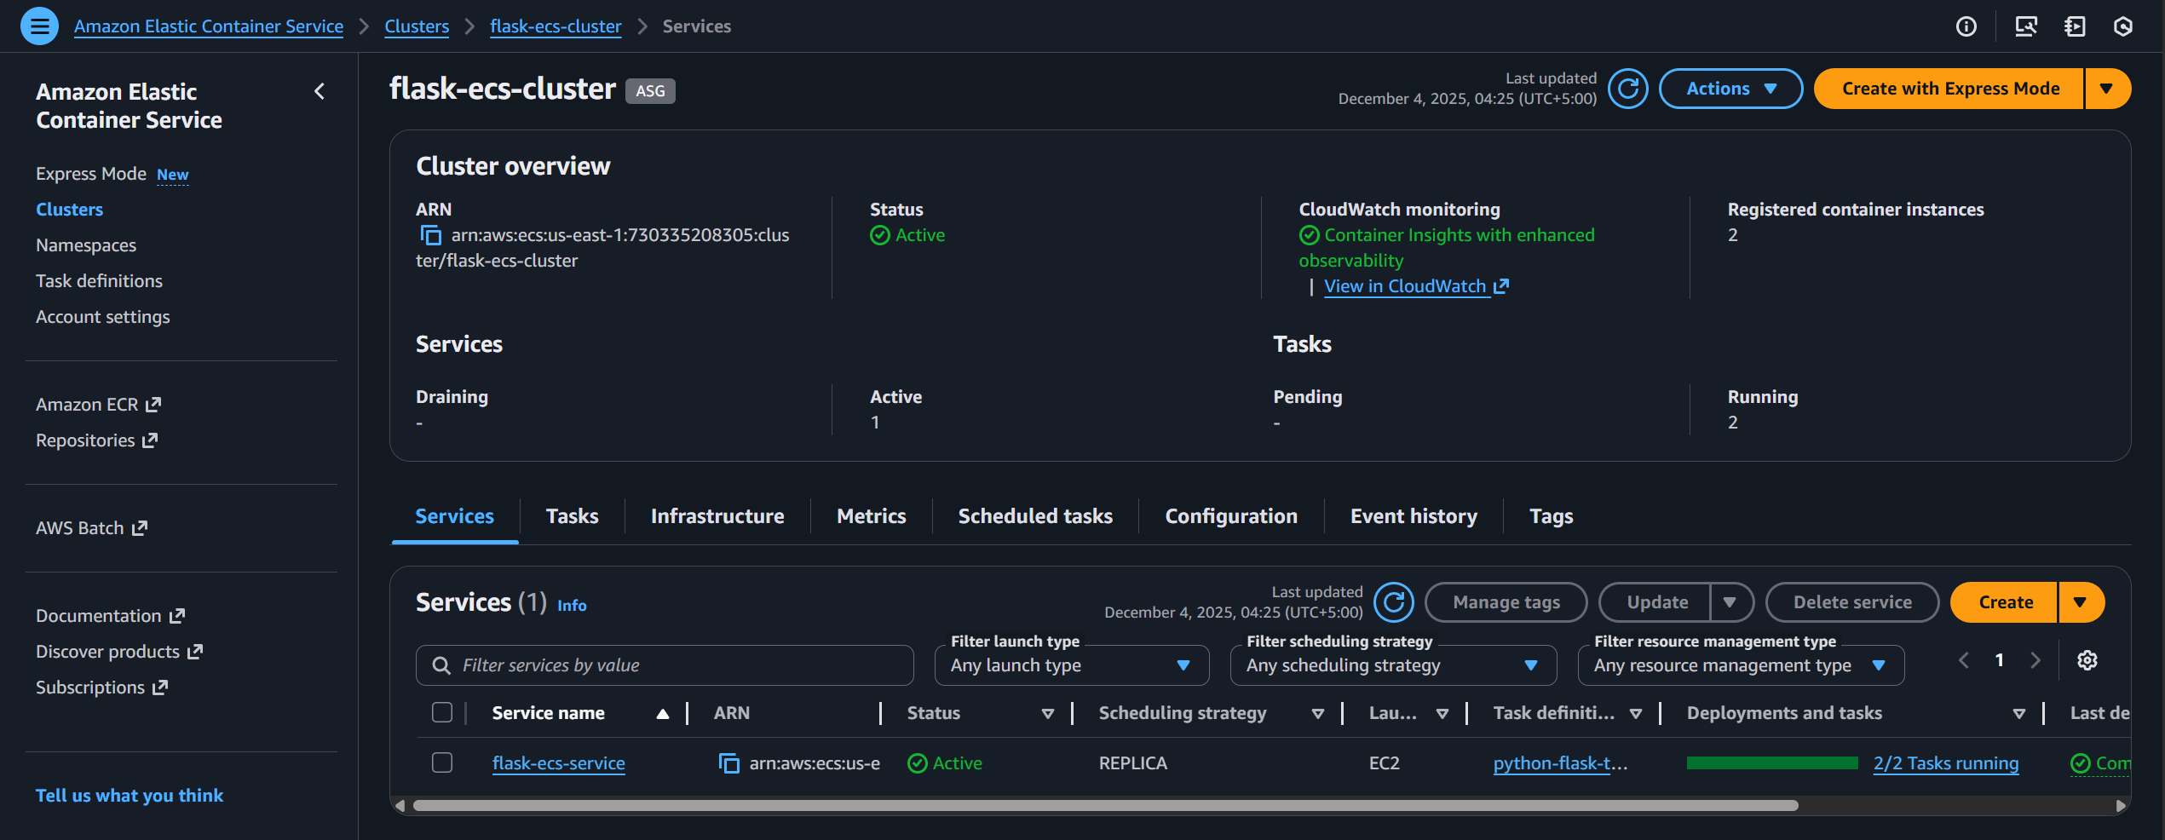

Then go toECS → Cluster  
Should show **2/2** running tasks**:**

**Step 5: Test Application**

Retrieve ALB DNS from AWS Console → EC2 → Load Balancers → ALB → DNS name

**Open in browser:**

http://<alb-dns-name>

A simple flask application should be displayed as shown below.

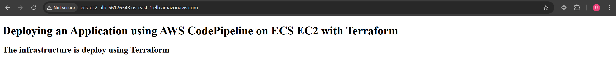

## Task 1.14: Deploy Flask Application via CodePipeline

1. Navigate to **CodePipeline** in the AWS Console.
2. Locate the pipeline created for your Flask app (e.g., flask-app-pipeline).
3. Click **Release change** or **Start pipeline execution**.
   * This triggers the pipeline:
     + **Source stage:** Pulls the code from your GitHub repository.
     + **Build stage:** CodeBuild builds the Docker image and pushes it to ECR.
     + **Deploy stage:** ECS service updates tasks with the new image.
4. Monitor each stage to ensure all steps succeed.
   * **Success:** The Build stage shows the Docker image pushed to ECR.
   * **Deploy stage:** ECS tasks are updated with the new Flask image.

## Task 1.15: Confirm Flask Application is Accessible

1. Navigate to **EC2 → Load Balancers**.
2. Copy the **ALB DNS Name** assigned.
3. Open a browser and paste the DNS.
   * You should see a simple Flask page.

## Task 1.16: Clean Up

To destroy all resources, run the following command

* *terraform destroy --auto-approve*

This removes VPC, subnets, ECS, ALB, ECR, CodeBuild, and CodePipeline resources.

# Troubleshooting

**Issue 1: VPC Client Error – DHCP Options**

**Problem Description:**  
CodeBuild or ECS provisioning failed with the following error:

* ***VPC_CLIENT_ERROR: Unexpected EC2 error: error while getting DHCP options for VPC***

**Root Cause:**  
The IAM role for CodeBuild did not include the "ec2:DescribeDhcpOptions" permission. CodeBuild needs this to query VPC DHCP settings for network interface creation.

**Solution:**  
Add "ec2:DescribeDhcpOptions" to the CodeBuild VPC policy in Terraform. After updating and applying, the provisioning succeeded.

**Issue 2: VPC Client Error – UnauthorizedOperation**  
 **Problem Description:**  
CodeBuild execution failed with:

* ***VPC_CLIENT_ERROR: Unexpected EC2 error: UnauthorizedOperation***

**Root Cause:**  
CodeBuild did not have sufficient permissions to create or attach network interfaces in the private subnets. When running in a VPC, CodeBuild must provision ENIs (Elastic Network Interfaces) to access resources, and it can only do this if the IAM role allows it to create network interfaces **and** authorize them in the specific private subnets.

**Solution:**  
Update the CodeBuild IAM role to allow the creation of network interfaces and explicitly permit CodeBuild to attach them to the private subnets. This ensures CodeBuild can launch build containers within the VPC and communicate with other resources securely.

**Issue 3: ECS Permissions Error in CodePipeline**

**Problem Description:**  
CodePipeline failed during the Deploy stage with a message:

The provided role does not have sufficient permissions to access ECS

**Root Cause:**  
CodePipeline was trying to update the ECS service, which requires passing the ECS task execution role. Without "iam:PassRole", CodePipeline cannot allow ECS to assume the role.

**Solution:**  
Add "iam:PassRole" to the CodePipeline IAM role policy. After updating, ECS tasks updated successfully with the new Docker image.

**Issue 4: GitHub Connection Requires Manual Update**

**Problem Description:**  
Pipeline execution failed at the Source stage. The AWS CodeStar GitHub connection showed **inactive** and required clicking **Update Connection** manually.

**Root Cause:**  
CodeStar connections sometimes require token refresh to remain active; Terraform cannot automatically refresh GitHub OAuth tokens.

**Solution:**  
Currently, manually click ***Update Connection*** in the AWS Developer Tools Console page to reactivate. Future improvements could involve storing GitHub tokens in **Secrets Manager** and automating token refresh, but this is not yet fully automated.